City Deal Executive and Stewardship Board

Date: 30 Sept 2016

Private and Confidential: NO
Communications Update

Report Author: Ginette Unsworth, Communications Programme Director, Lancashire County Council

- Executive Summary

1.1 This report provides an update on inward investment marketing and will be accompanied by a discussion at the meeting with Ruth Connor, Chief Executive Marketing Lancashire and Simon Turner, Managing Director of Freshfield. The report also provides an update on day to day communications and marketing activity.

- Recommendations

  - Consider the ongoing work on the City Deal investment offer;

  - Request that a further presentation on this work be brought to the Executive and Stewardship Board at its meeting in November;

  - Agree that the City Deal key messages, set out in this report, be further developed for use at MIPIM; and

  - Note the updates on activity to date.

- Inward Investment marketing

  - Ensuring we have a consistent inward investment narrative is vital to ensure we are attracting high level commercial investors into central Lancashire over the coming next few years. Following agreement by the E&SB, Freshfield has been commissioned to pull together an inward investment narrative for investors and developers, promoting the commercial opportunities available in the City Deal area. The narrative will highlight the opportunities available to investors in the city centre and district centres, including projects underway and in the pipeline. This work will support the production of collateral to be used at events, and the wider promotion of the City Deal programme. Freshfield will present at the meeting an update of how they see the narrative being positioned and will seek agreement on formats and direction of travel for the work. The timing of this narrative is important to ensure that all the great stories that are likely to come to fruition in the next few months can be included.
3.2 In the 6-month period between October 2016 and March 2017 there will be a number of key milestones which will be of significance to the inward investment narrative in adding content to the story as well as opportunities for further announcements, for example news on the Preston Cinema scheme, development of the City Centre Living strategy, Preston Railway Station and Cuerden.

- Business events

  - Lancashire will have a presence at the MIPIM UK stand in October through Marketing Lancashire. The primary focus of the Lancashire stand will be the LEP's family of Enterprise Zones. Marketing Lancashire have made available a sponsorship opportunity to district councils, many of whom will use the opportunity to promote their local projects in a digital presentation which will be displayed on ipads. The timing of MIPIMUK is too early to showcase the City Deal investor offer because of the timescale of the release of key projects as outlined above, therefore the flagship investment proposition at the conference will be the Enterprise Zones.

  - However, it is important that City Deal still forms part of the conversations for the City Deal partners to promote the following City Deal messages and ensure consistency of approach:

- Located - Central Lancashire sits at the heart of the £23bn Lancashire economy supporting more than 620,000 jobs in 45,000 businesses.
- Connected - A value added location close to Manchester and Liverpool connected to the rest of the UK and global markets via the M6, M61, M65, the coast and airports. Preston railway station is a major regional asset on the future HS2 route - the optimum Northshoring location.
- Commercial - Major development is taking place anchored by new public spaces. New developments at the advanced manufacturing Enterprise Zone, Preston City Centre, UCLan and Cuerden are creating new jobs, transforming leisure facilities, and providing new commercial opportunities.
- Skilled - Preston is home to the University of Central Lancashire (UCLan), world-class and forward thinking, delivering a £200m campus masterplan. With nationally acclaimed sixth form colleges Cardinal Newman College and Runshaw College. Targeted Skills and Employment Action Plan ensures we have skills to match jobs and growth
- Great Place to Live - The City Deal area is providing a comprehensive housing offer. From affordable starter homes, student targeted accommodation, and City Centre private rented units for young professionals and families, through to large family houses and retirement homes. All close to the Coast, Lake District and Yorkshire Dales.
- Green and Open. Historic City Centre parks, connected green corridors, and new public squares are at the heart of Central Lancashire.
  - A City Deal event run by Place North West will take place at RSM (formerly Baker Tilly) offices on Tuesday 7 February 2017 and will be the launch of the inward investment narrative and start to promote the opportunities that are available to a wider audience across the north west region and beyond.

- Activity as part of the communications and marketing delivery plan

  - Media
The last quarter has seen a number of milestones for public information, communication and consultation. The visual below depicts the outcomes achieved over the last two years and was used to support a media release and push the message online.

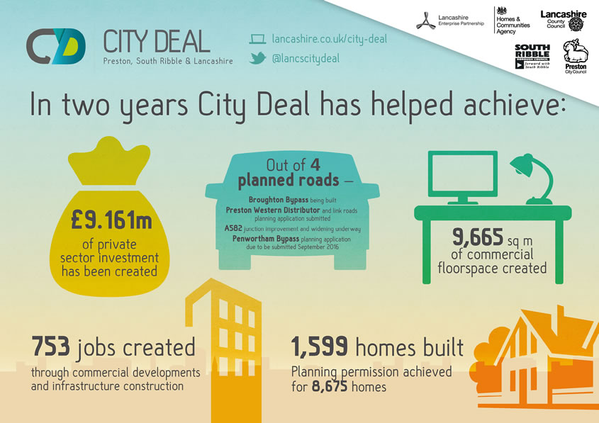

Activities have included media releases on the following:
- Moving the tank to make way for roundabout improvements
- Preston Western Distributor planning application submitted
- £3.5M announced for Bamber Bridge improvements
- Engineering students visit Broughton Bypass site
- Penwortham Bypass consultation launched
- New hotel planned at East Cliff site
- New hotel planned at former post office site
- First housing development sells out
- City Deal stand at UCLAN science festival
- Plans for Preston bus station
- A582 improvements at Pope Lane roundabout
- City Deal progress two years on
- Land deal on former Leyland Motors test track
- Improvement work along Fishergate
- Improvement work at tank roundabout on A582
- Traffic restrictions on New Hall Lane
- Planning application submitted for Preston Youth Zone
- 300 new family homes for Preston
- New tractor gateway feature for South Ribble

  - Online content
The 'near you' section of the City Deal area of the LEP website has been enhanced to ensure improved navigation and an easier layout for all of the new information that has been added due to growing projects.

  - Penwortham Bypass consultation
Pre planning application events were organised to consult on the Penwortham Bypass and town centre improvements and people could share their views as part of an on-line consultation. Letters were distributed to 13,000 residents in the area and the events were also promoted via newsletters, media and social media. Over 320 people attended the events and viewed the display boards explaining the plans in more detail and around 300 responses have been received to date.

- Coming up
Key forthcoming milestones to be supported by communications activity include:
  - Update on Cuerden development site.
  - Planning applications for a number of housing sites
  - Planning application submitted for Penwortham Bypass
  - First works start on bus station improvements

